Spanish 1-2, “Para empezar” Weather Project

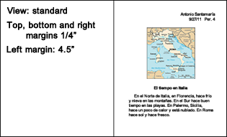
¿Qué tiempo hace hoy en . . . ?

- Look for an online map of the Spanish speaking country you were assigned with 3 major cities on it. (10 points)
- Find the name of the country and 3-4 major cities in Spanish. Find what the weather is like there now in the north, south, east, west, northwest, etc.
- With both map and weather forecast, write the 1st draft of a weather report in Spanish. Use the vocabulary and the model provided below. (10 points if double-spaced and complete)
- When you finish the first draft, ask two students in class to peer correct your 1st draft. (5 points each of 2 names at the bottom of your 1st draft and peer corrections on your 1st draft).
- Write a 2nd draft incorporating the corrections suggested by your peers and turn it in to your teacher for help. (10 points for the 2nd draft if it is double-spaced and complete)
- Now use the template on SchoolLoop to type your project. Include a map of your country, a title (El tiempo en your country) and the weather. Then type, single-space, your forecast using 12 point Arial. (10 points each for the writing part of the final project and a country map.

VOCABULARY

• Cardinal points in Spanish • More vocabulary
- Está nublado (It’s cloudy).
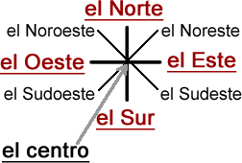
- A little with clouds and precipitation
- Está un poco nublado (It’s a little cloudy). Use un poco
with nublado. Notice that it goes in front. With precipitation un poco goes behind the llueve and nieva (Llueve un
poco en Roma.)

- A little with hot and cold-> un poco de
- Hace un poco de calor. (It’s a little hot.) Hace un poco de
frío.

- Very
- Hace mucho frío.

- Place names
- Las montañas
- Las playas

MODELTEXT

El tiempo en Italia

En el norte de Italia, en Florencia,
hace frío y nieva en las montañas. En el
sur hace buen tiempo en las playas. En
Palermo, Sicilia, hace un poco de calor y
está un poco nublado. En Roma hace sol y
hace fresco.

